Experiment 4:- Implement C program for Binary search using Divide and Conquer Approach

Program:-

#include <stdio.h>
int binarySearch(int arr[], int left, int right, int target) {
if (left <= right) {
int mid = left + (right - left) / 2;
if (arr[mid] == target) {
return mid;
}
if (arr[mid] > target) {
return binarySearch(arr, left, mid - 1, target);
}
return binarySearch(arr, mid + 1, right, target);
}
return -1;
}
int main() {
int n, target, result
printf("Enter the number of elements in the array: ");
scanf("%d", &n);
int arr[n];
printf("Enter %d elements in ascending order:\n", n);
for (int i = 0; i < n; i++) {
scanf("%d", &arr[i]);
}
printf("Enter the value to search: ");
scanf("%d", &target);
result = binarySearch(arr, 0, n - 1, target);
if (result == -1) {
printf("Element not found in the array.\n");
} else {
printf("Element found at index %d.\n", result);
}
return 0;
}

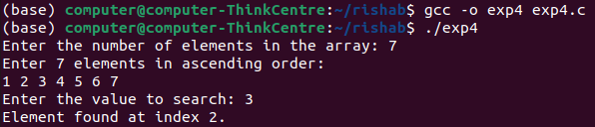
Output:-

